Lab 02b - Manage Governance via Azure Policy.

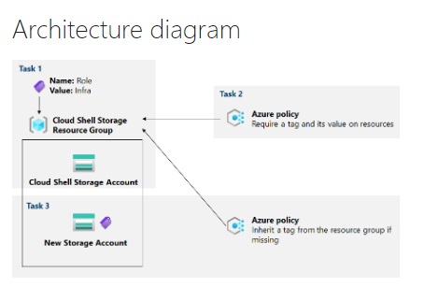

* Task 1: Create and assign tags via the Azure portal.
  + In this task, you will create and assign a tag to an Azure resource group via the Azure portal.

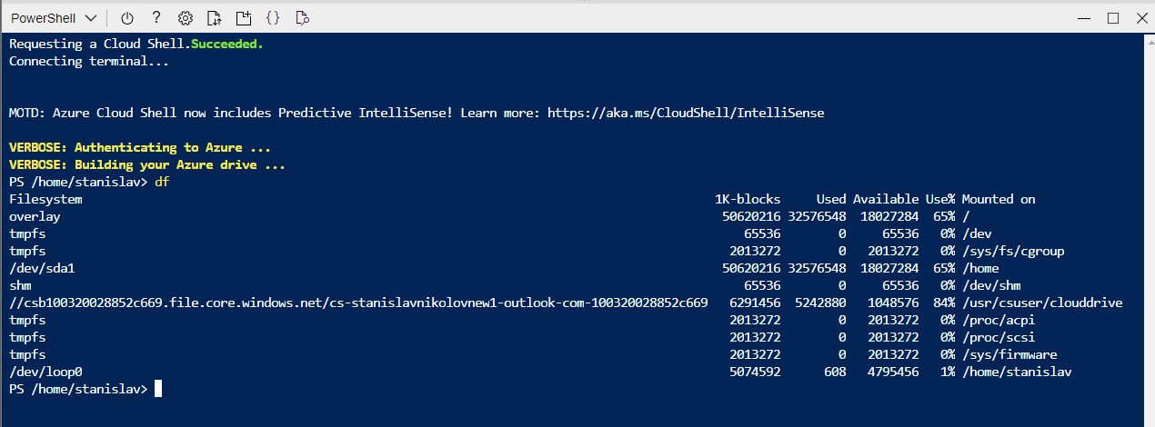

* + path designating: csb100320028852c669 and creating a new tag

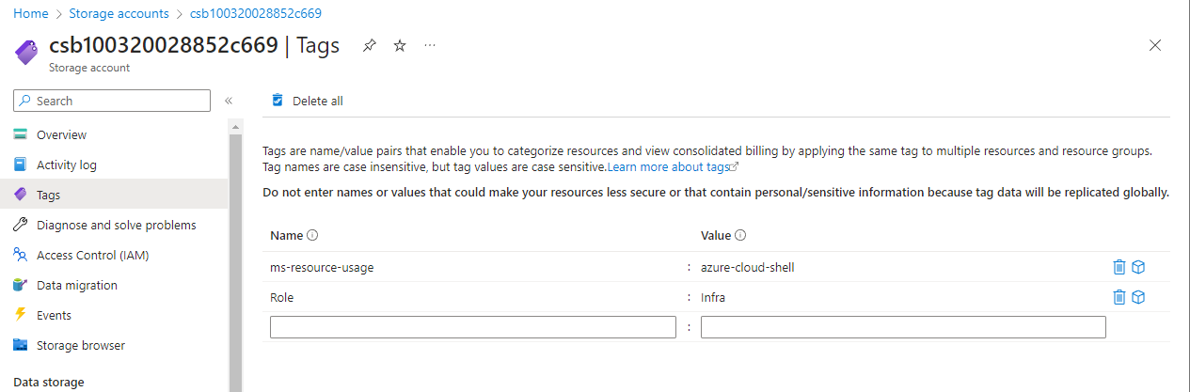

* Task 2: Enforce tagging via an Azure policy.
  + In this task, you will assign the built-in Require a tag and its value on resources policy to the resource group and evaluate the outcome.

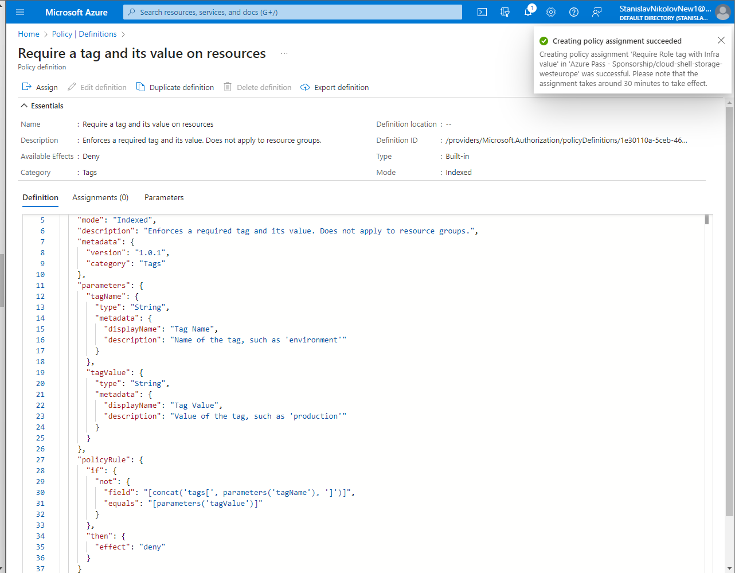

* + Creating an assignment policy

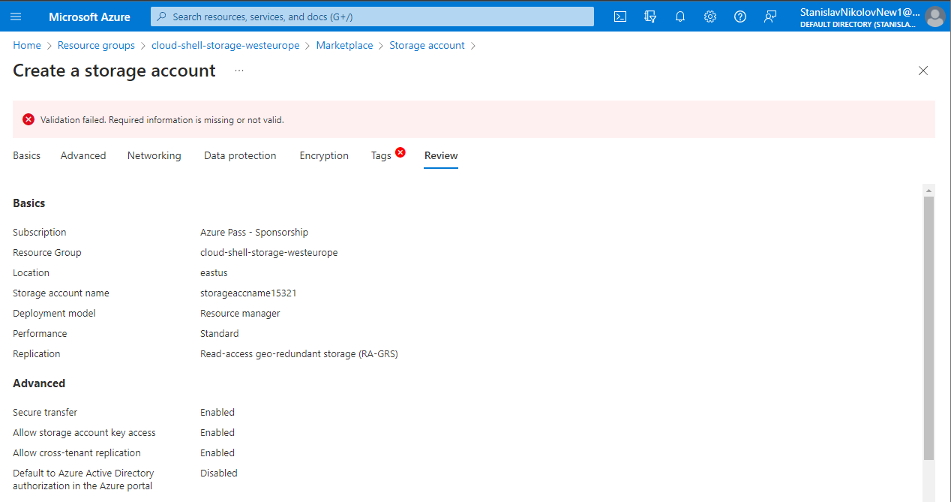

* + Expected validation error, which we can fix by adding the tag.

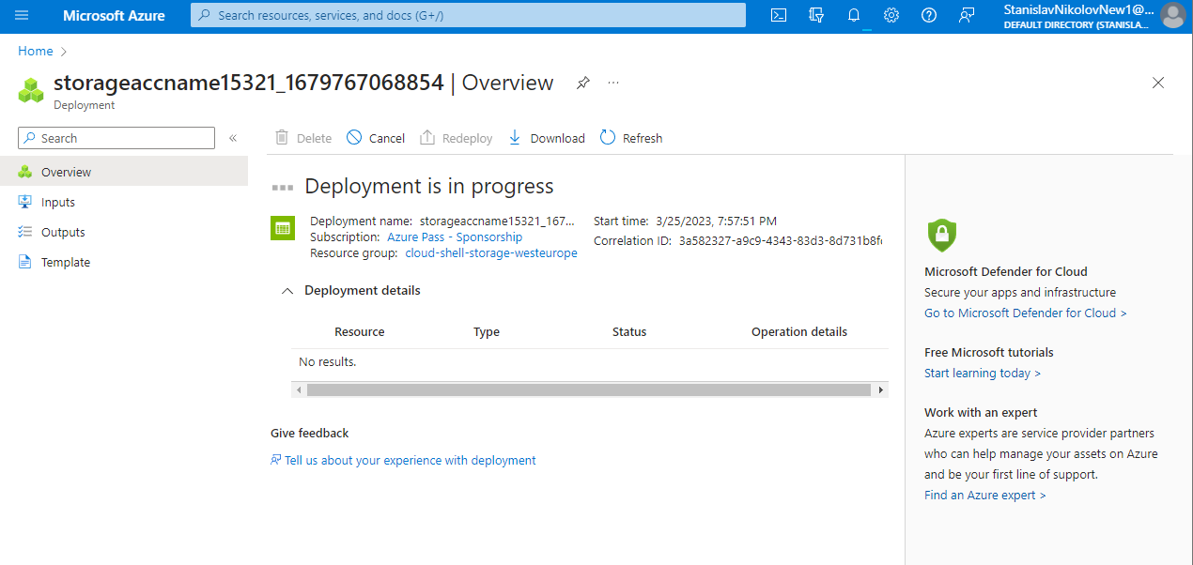

* + Created new Storage Account.
* Task 3: Apply tagging via an Azure policy.
  + In this task, we will use a different policy definition to remediate any non-compliant resources.

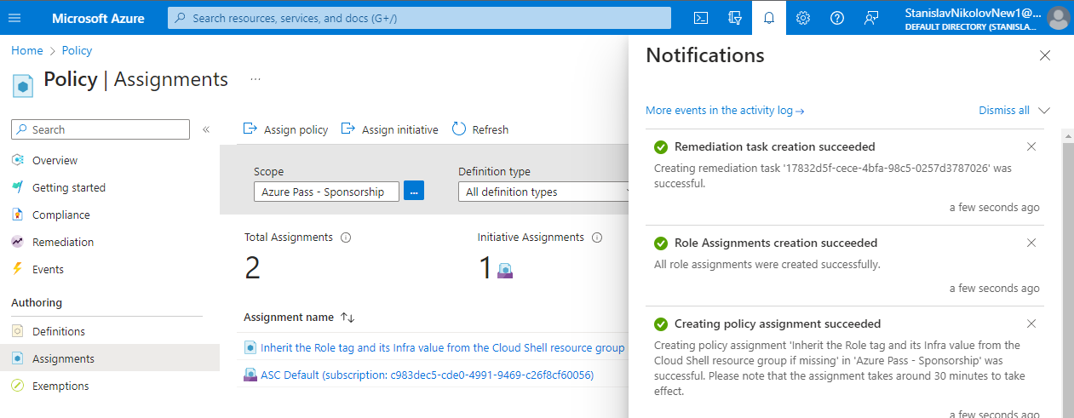

* + Creating a new assignment policy.

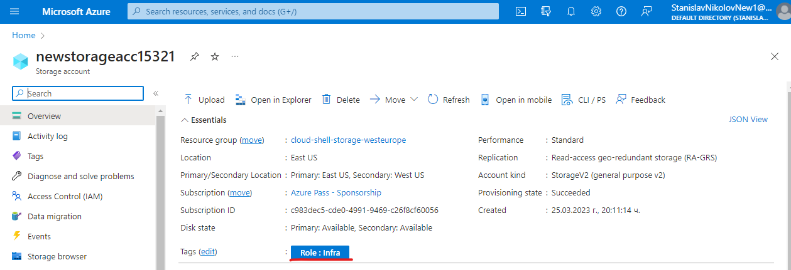

* + Creating new storage account, with automatically assigned tag Role: Infra.